Program 1

Java program to Print an Integer (Entered by the User)

Code :

import java.util.Scanner;

public class helloworld{

public static void main(String[] args) {

System.out.println("AJAY.N.M\n1BM22CS026");

Scanner reader = new Scanner(System.in);

System.out.print("enter a new number : ");

int number = reader.nextInt();

System.out.println("you entered : "+ number);

}

}

Output:

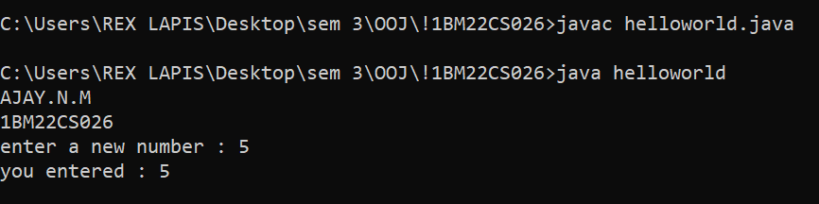

Program 2

Java Program to Check Whether a Number is Even or Odd

Code :

import java.util.Scanner;

public class javaexample {

public static void main(String[] args){

System.out.println("AJAY.N.M\n1BM22CS026");

int num;

System.out.println("enter a integer:");

Scanner input = new Scanner(System.in);

num = input.nextInt();

if (num % 2 == 0){

System.out.println(" even number");}

else

{System.out.println(" odd number");

}

}

}

Output:

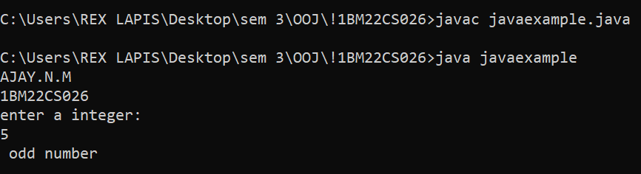

Program 3

Java Program to Print Right Triangle Star Pattern

Code :

import java.util.Scanner;

public class Star

{

public static void main(String args[])

{

System.out.println("AJAY.N.M\n1BM22CS026");

int row, column, numberofrows=8;

for(row=0; row<numberofrows; row++)

{

for(column=0; column<=row; column++)

{

System.out.print("\*");

}

System.out.println();

}

}

}

Output:

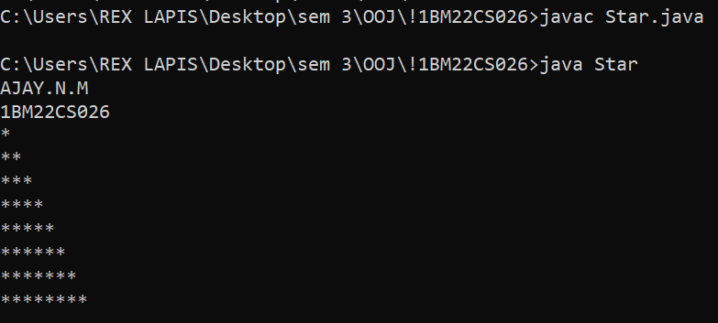

Program 4

Java Program to Find Quotient and Remainder

Code :

import java.util.Scanner;

public class qr{

public static void main(String[] args){

System.out.println("AJAY.N.M\n1BM22CS026");

int num1 = 15,num2=2;

int q = num1 / num2;

int rem = num1 % num2;

System.out.println("quotient is:" + q);

System.out.println("Remainder is:" + rem);

}

}

Output:

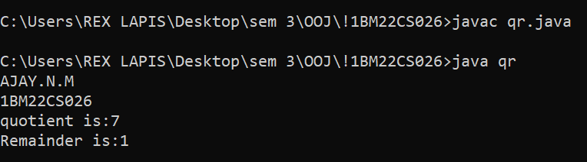

Program 5

Java Program to Multiply Two Numbers

Code :

import java.util.Scanner;

public class multiply {

public static void main(String[] args){

System.out.println("AJAY.N.M\n1BM22CS026");

Scanner scan = new Scanner(System.in);

System.out.println("enter first number:");

int num1 = scan.nextInt();

System.out.println("enter second number:");

int num2 = scan.nextInt();

scan.close();

int m = num1\*num2;

System.out.println("Output:"+m);

}

}

Output:

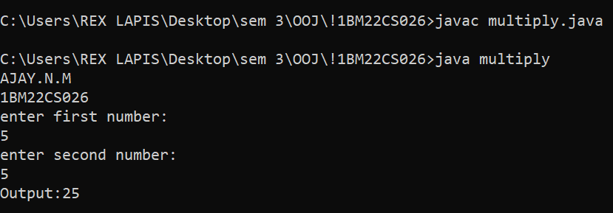

Program 6

Swap two numbers using temporary variable

Code :

import java.util.Scanner;

public class swap{

public static void main(String[] args) {

System.out.println("AJAY.N.M\n1BM22CS026");

float first = 1.20f, second = 2.45f;

System.out.println("--before swap--");

System.out.println("first number = "+first);

System.out.println("second number = "+second);

float temp = first;

first = second;

second = temp;

System.out.println("--after swap--");

System.out.println("first number = "+first);

System.out.println("second number = "+second);

}

}

Output:

